## PHASE 6: LIGHTNING UI

**Lightning App Creation**

* App Name: Smart Delivery Hub
* Developer Name: Smart_Delivery_Hub
* Features Enabled:
  + Navigation Bar
  + Utility Bar
  + Lightning Experience (mobile + desktop)

App Navigation:

* Home Tab (dashboard overview)
* Deliveries Tab (core, default landing)
* Drivers Tab (assignment and status mgmt)
* Hubs Tab (territory/resource mgmt)
* Reports Tab (for analytics/KPIs)

User Setup:

* Accessible to System Administrator by profile
* Custom Permission Sets for delivery-specific features
* App visible to authorized users only

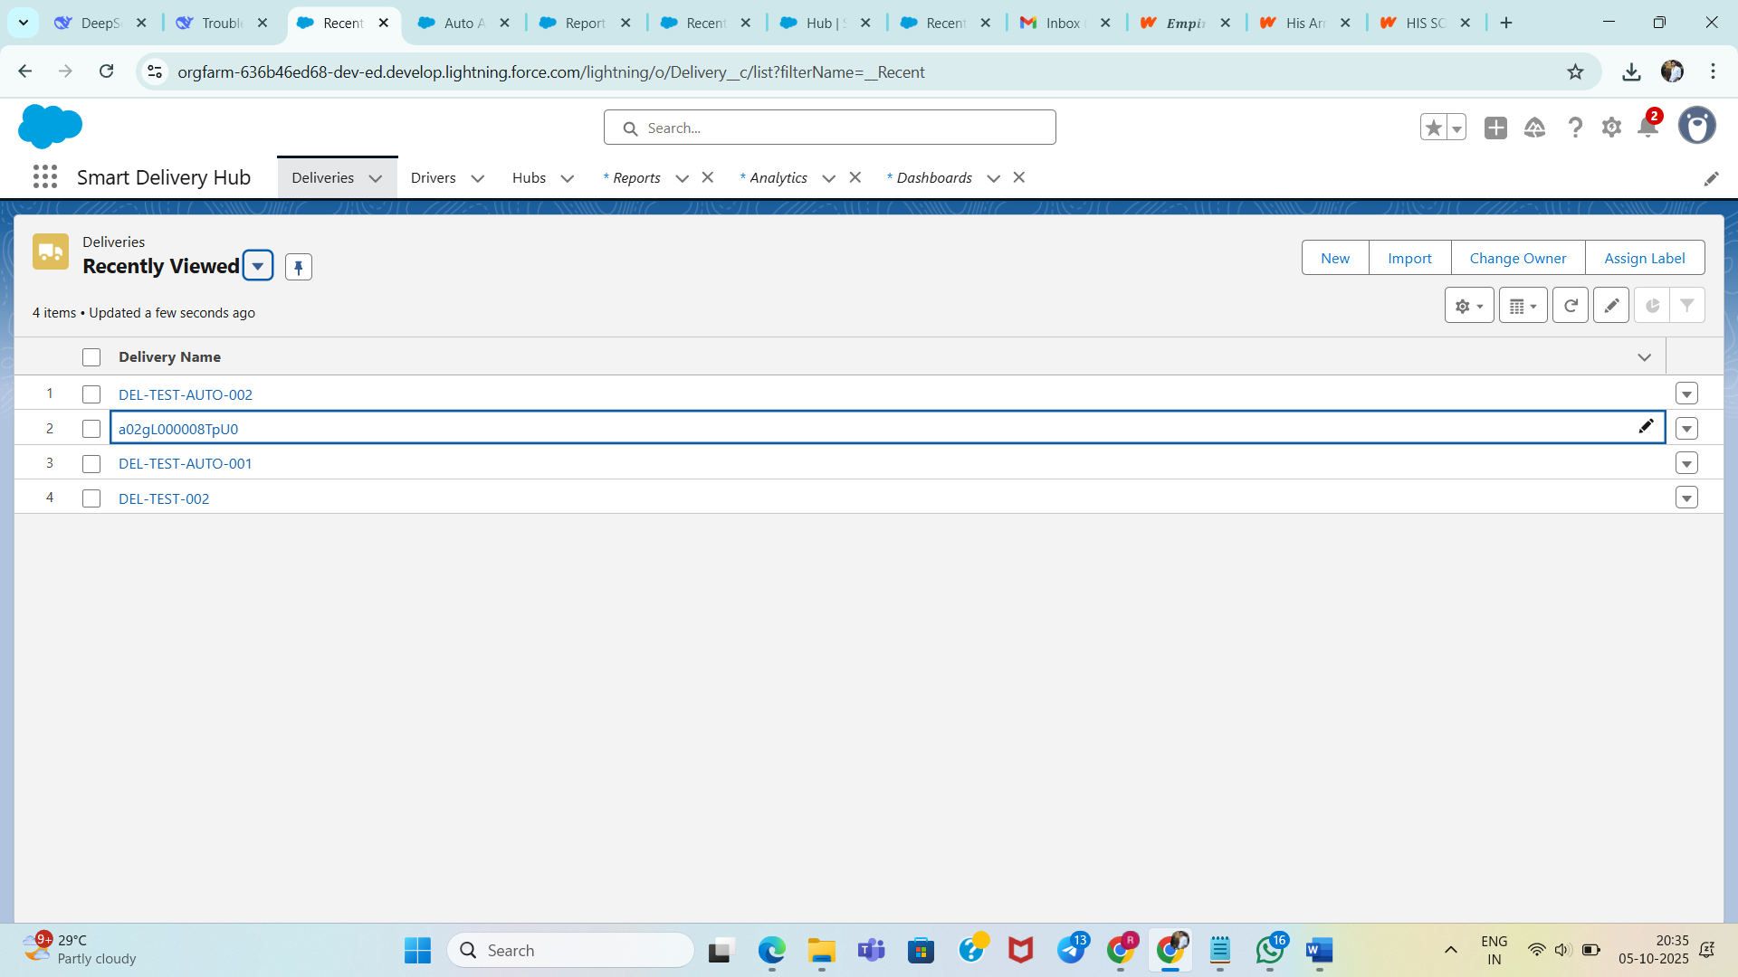

**Record Page Customization**

Delivery Record Page

* *Header:*
  + Delivery Number
  + Customer Name
  + Status (highlighted)
* *Main Section (Left):*
  + Customer details
  + Location, schedule info
* *Sidebar (Right):*
  + Assigned Driver
  + ETA and Distance
  + Quick Actions (buttons)

Lightning Components:

* Details (field info)
* Related Lists (tasks, activities, feedback)
* Actions Container (Mark as Delivered, Report Failed Attempt)
* FlexiPanel (custom info like delivery attempts)

Quick Actions:

* *Mark as Delivered:* Updates status, sets timestamp
* *Report Failed Attempt:* Sets status as Failed, increments attempt count, creates follow-up task

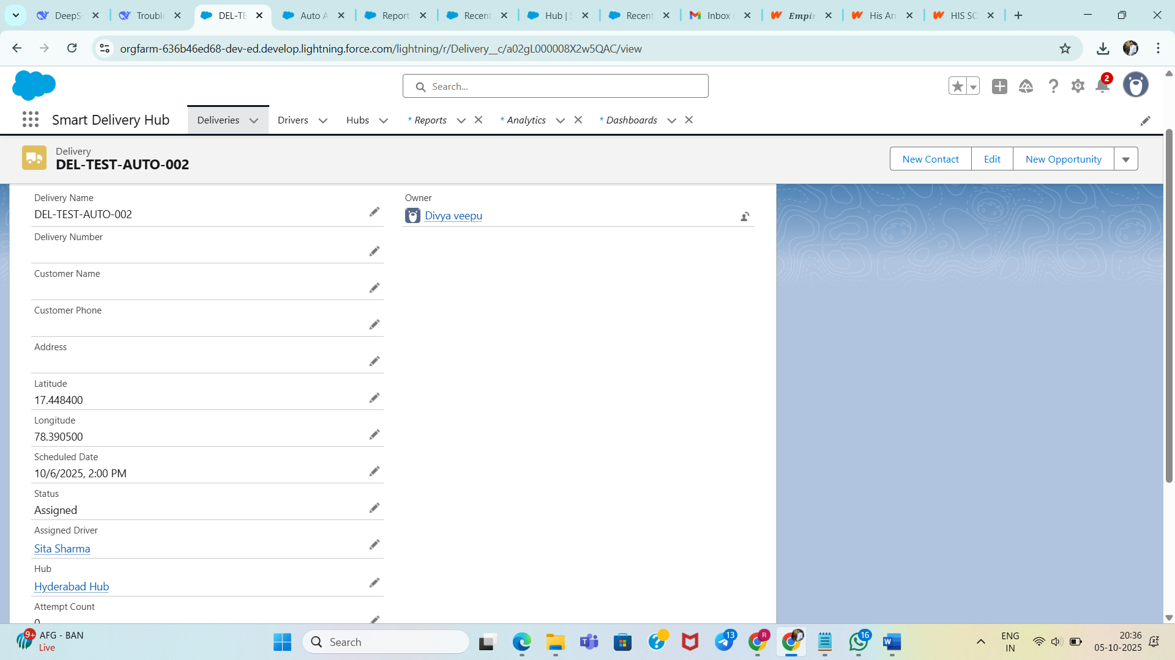

Mobile Optimization

* Responsive layout adapts to mobile
* Large touch-friendly buttons/forms
* Basic offline updates supported for field drivers

Driver Record Page

* Shows current location/status
* Related deliveries in list
* Actions for updating availability/location

